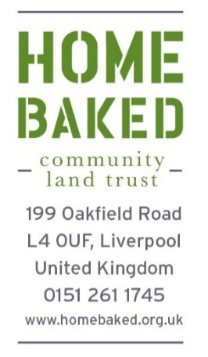

Housing Application

If you have any questions, please don’t hesitate to contact John McGuigan on 0151 7262200. Please email completed form to John McGuigan at North West Housing (John.McGuigan@nwhousing.org.uk).
Full Name

Date of Birth | Male Female
Relationship status

Email Address
Mobile Number

Current Address
How long have you lived here?
If less than 3 years, please give previous address

Do you have children who will live with you: Yes or No

Please give ages if yes

Do you have any pets: Yes or No
What Type
Are you a smoker: Yes or No

Please tell us about your current housing situation
Are you living with family: Yes or No
Are you living with friends: Yes or No
Are you renting your property: Yes or No

If yes, who is your landlord

How long have you lived there

How much rent do you pay

Why are you interested in moving into a property owned by Homebaked CLT?

Are you involved in any other community groups or other organisations. Please tell us what you do?

Are you employed: Yes or No Please give details
Company name

Position

Annual Salary

Start Date

Full or part time

Permanent/contracted

Are you self-employed: Yes or No Please give details

Company name

Start date

Business Type

Annual Income

Are you unemployed: Yes or No
If yes, please provide more information

Is there anything else you want to tell us about your financial situation

Is there anything else you want to tell us to support your application

Please provide 2 references e.g. an employer or landlord
- Name, email, phone number, relationship to you

- Name, email, phone number, relationship to you

I confirm that the information provided by me is true to the best of my knowledge. I consent to my information being verified by an external third party
Print Name
Signature Date

